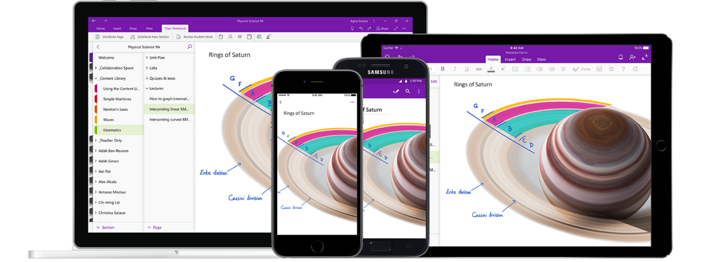

*Figure 1 cited from* [*Microsoft OneNote’s Official Website*](https://www.microsoft.com/zh-cn/microsoft-365/onenote/digital-note-taking-app?ms.url=onenotecom&rtc=1)

Title

INFO200 Position Paper | Feb 19th, 2021 | Hairong Wu (Jason) | 1706 words

# Introduction

Provide a brief description of the issue, the surrounding context, and the question you will be addressing. This should explain enough so that someone unfamiliar with the issue can quickly get oriented and be ready to follow your argument.

Articulate your answer to the question, along with evidence supporting your opinion. This evidence should come from the articles, additional sources, and/or course materials you consulted during your research. Your position can be nuanced and in the middle; it doesn't have to be on the extremes of the debate.

If you want to take a more nuanced position on your topic, simply providing the opinions for and against the general points is not sufficient; you should be directly and purposefully advocating for it throughout your paper.

Acknowledge one or two arguments that could be made against your position. Not everyone will agree with you, and there may be legitimate arguments against your point of view. Demonstrate that you recognize and understand the counter-argument(s).

Explain why you think your argument is more convincing than the counter-argument(s), and why the evidence is in your favor.